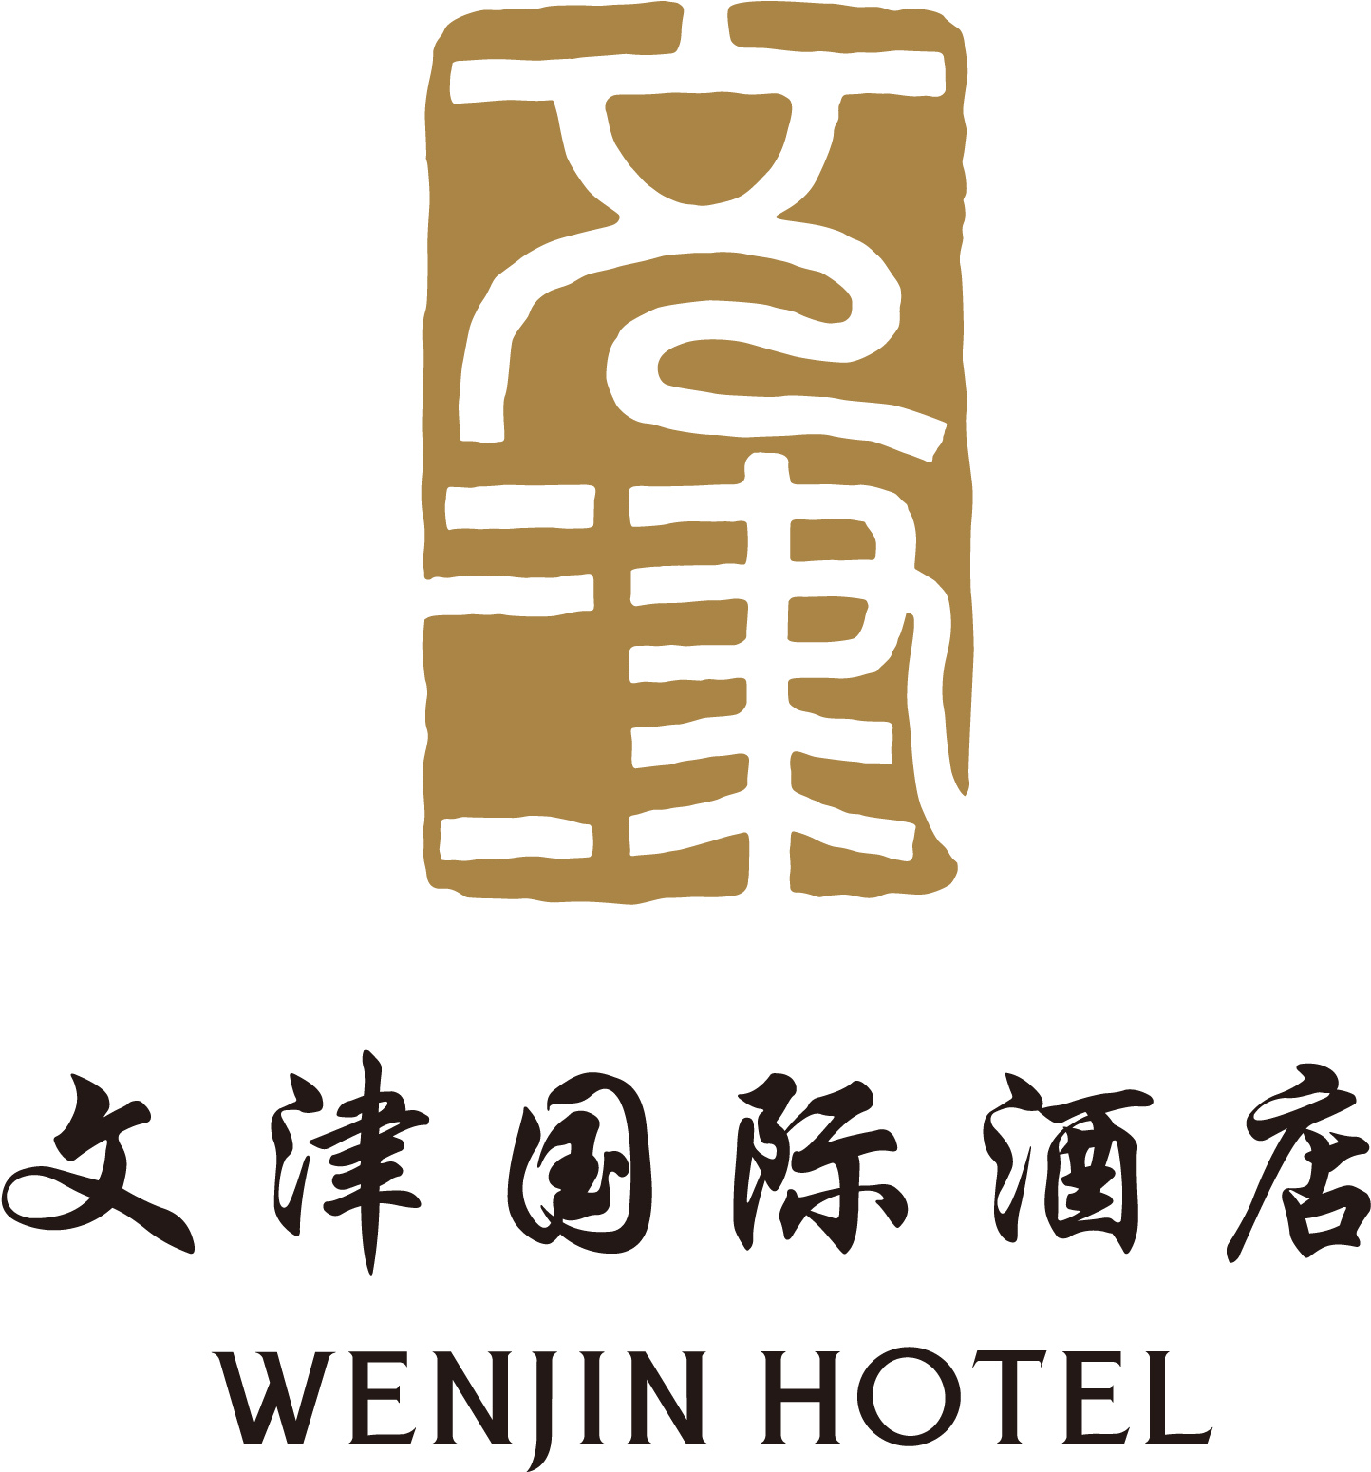

WENJIN HOTEL ROOM RESERVATION FORM
文津国际酒店客房预定单

单位名称： Global Transitions Conference 2019
Company Name: Global Transitions Conference 2019

宾客姓名：
Guest Name：

到店日期： 离店日期：
Arrival Date： Departure Date：

房型和数量（请选择）
Room Type and Quantity of Rooms (please select)
房型  Room Types | 房价  Room Charge | 数量  Quantity of Room
高级大床房  Superior Room with King Bed | 798元/晚  RMB 798 / night
高级双床房  Superior Room with Two Twin Beds | 798元/晚  RMB 798 / night
商务大床房  Business Room with King Bed | 898元/晚  RMB 898 / night
商务双床房  Business Room with Two Twin Beds | 898元/晚  RMB 898 / night
备注：房间包含1份早餐、免费宽带上网、免费使用健身房。
Note: The room charge includes single breakfast, internet and gym.

请用信用卡支付房费并填写表格内容：
Please pay the room charge by credit card and complete the form：
信用卡号：
Credit card No:__ __ __ __ /__ __ __ __ /__ __ __ __ /__ __ __ __
有效期至：
Expiry Date: __ __ /__ __
持卡人姓名：
Cardholder Name _________________________
持卡人住址：
Cardholder Address___________________________________________________
持卡人签名：
Cardholder Signature__________________________
请发送传真到文津酒店86-10-82621556
Please fax the form to Wenjin Hotel 86-10-82621556.
或发送电子邮件至reservation@wenjin.com.cn
Or send the E-mail to reservation@wenjin.com.cn

酒店总机是86-10-62525566
Hotel operator is 86-10-62525566.
如果您需要接机服务，请联系礼宾部。分机为5013
If you need airport pick up service, please contact concierge department, the extension is 5013.
Chinese note to show to the taxi driver:
师傅，您好！请送我到文津国际酒店。地址：北京市海淀区清华科技园清华大学南门

请于5月25日之前做好预定，否则根据酒店的预订情况房间价格会高于以上价格。
Please make the hotel reservation before May 5 , or the room charge will be higher

