A Concise and Informative Title of Letter/article/review
Given Name Family Name ^{a,1}, Full Name ^{a,1}, Full Name ^{b}, Full Name ^{b}, Full Name ^{a,*}, Full Name ^{b} and Full Name^{b,}*
ª Address, Address, City, Postcode, Country.
^{b} Address, Address, City, Postcode, Country.
Abstract: Please provide an abstract of 150 to 300 words. The abstract should be a single paragraph which summarizes the content of the article, including the background and scientific questions, research aim, preparation process, main data and results, novelties and prospect. The abstract should not contain any undefined abbreviations or unspecified references.
Keywords: The first one; The second one; (Please provide 3 to 6 keywords which can be used for indexing purposes.)

TOC figure: A graphical abstract is mandatory. It should symbolize the topic of the article pictorially, at a glance, to capture the attention of a wide readership online. Please design an image that is easy to comprehend when viewed at the size, 5.6 cm height * 10.0 cm width, using a resolution of 300 dpi.

1. Introduction
The introduction should introduce the research background, put forward the research questions, state the research objectives, point out the innovation points of the paper. Provide a brief summary of the previous literature and results, but avoid lengthy discourse and review.
Reference citations in the text should be identified by numbers in square brackets. Some examples: Negotiation research spans many disciplines [1,2]. This result was later contradicted by Becker and Seligman [3]. This effect has been studied [1-3, 4].

2. Results and discussion
2.1 Second-order heading
The results and discussion section should be organized by using appropriate sub-headings. Use the automatic page numbering function to number the pages. Do not use field functions. Use tab stops or other commands for indents, not the space bar. Use the table function, not spreadsheets, to make tables. Use the equation editor or MathType for equations.
Figures and Tables should be inserted at/near the page where they are first mentioned. For example, the synthesis process involves the preparation of Ca-PpIX nanoparticles and then coating with M1 macrophage cell nanovesicles (Fig. 1a). Transmission electron microscopy (TEM) images confirm that the Ca-PpIX@M have an irregular morphology and a thin shell of ~8 nm compared to Ca-PpIX (Fig. 1b). Please use a, b, c to indicate the different Panels, as shown in Fig.1
For the revision stage, please insert Figures in the paper word and simultaneously supply all separated figure files (eps, tiff).
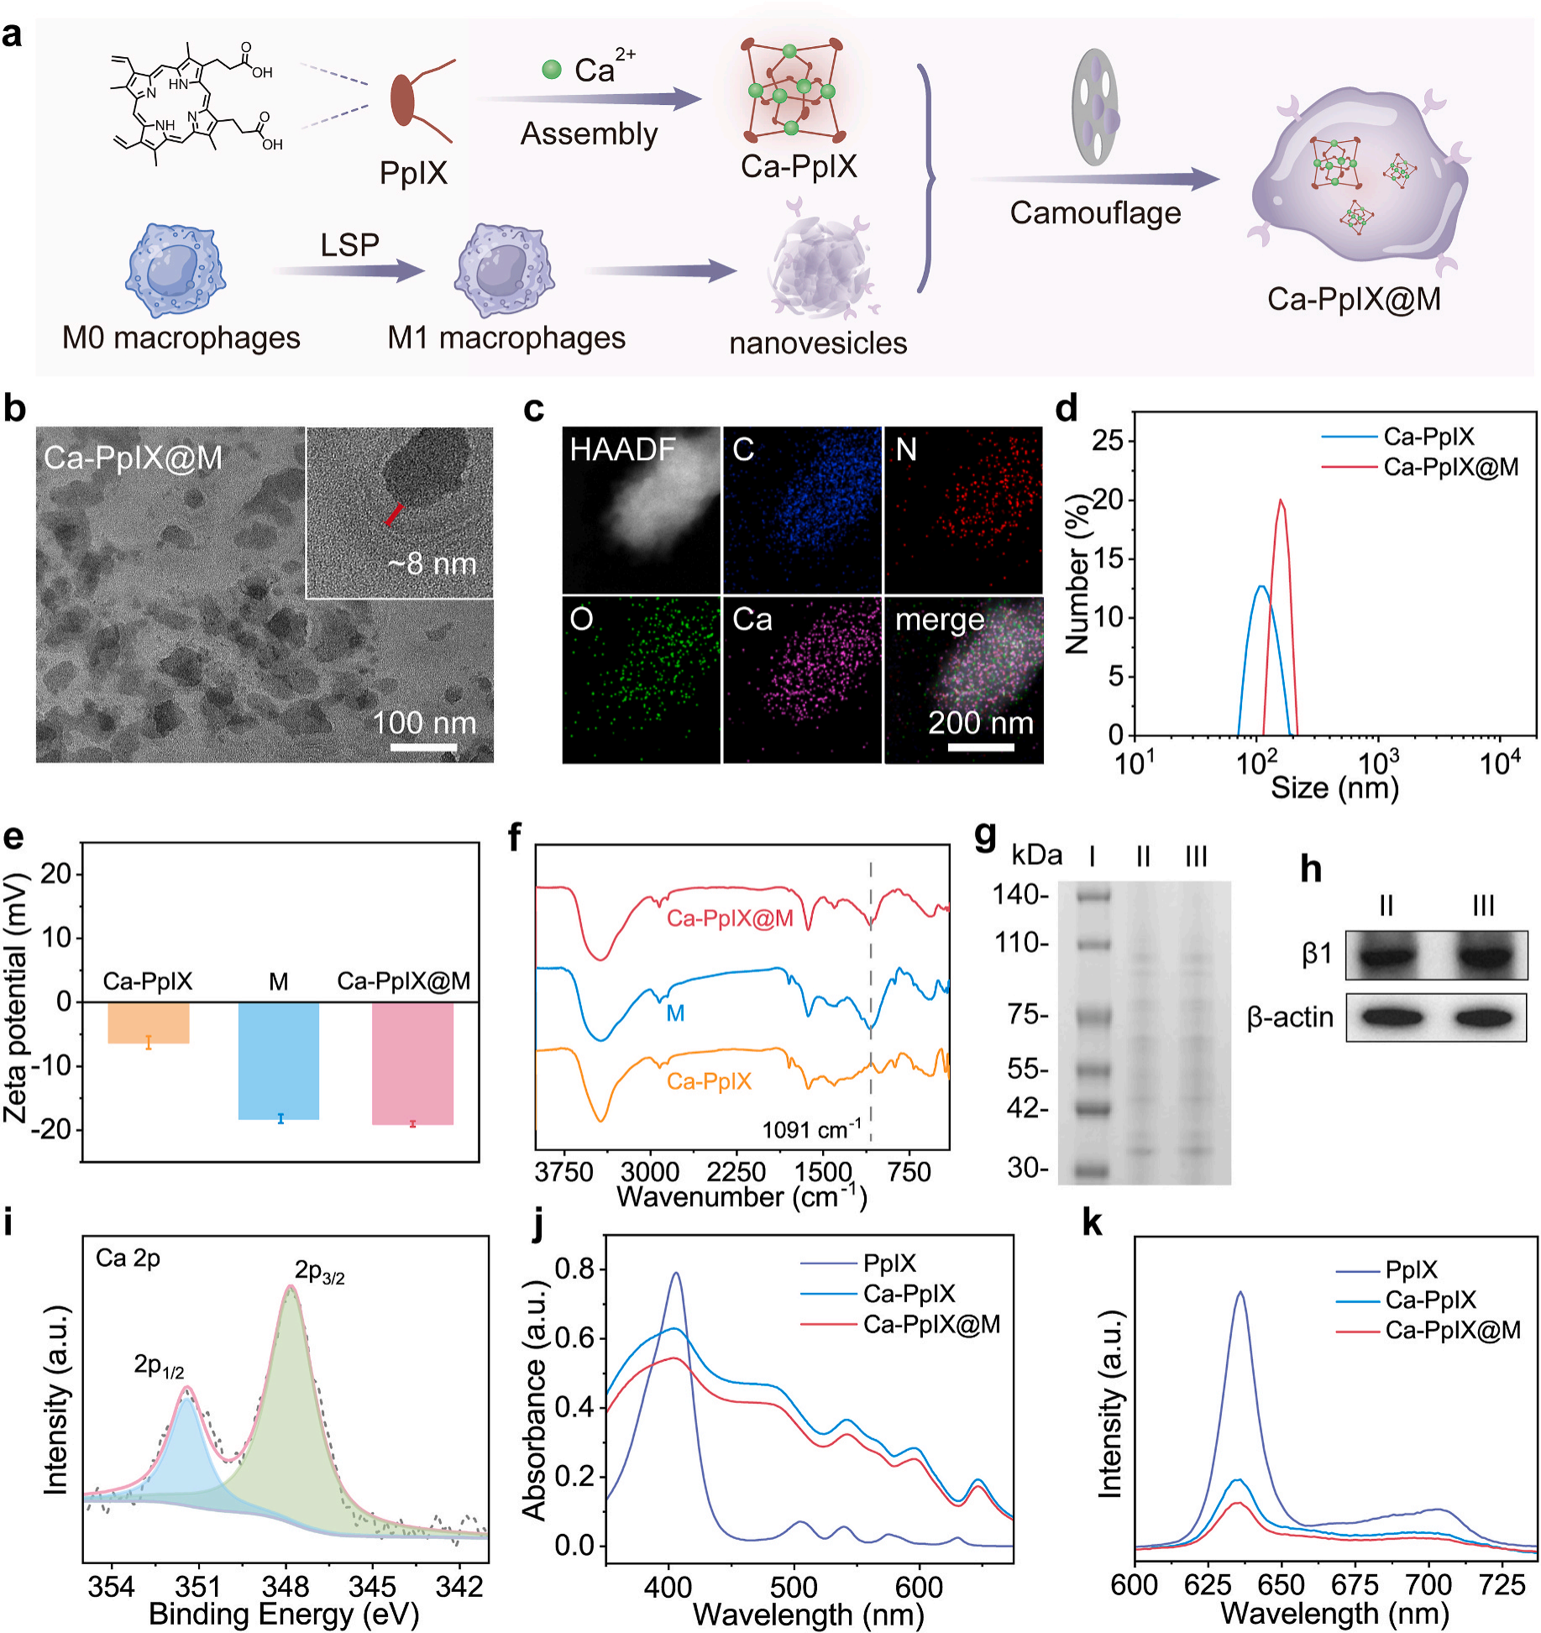
Fig. 1 Characterizations of Ca-PpIX@M. (a) Schematic diagram of Ca-PpIX@M preparation. (b) TEM and (c) HAADF-STEM image and element maps of Ca-PpIX@M. (d) The hydrodynamic size of Ca-PpIX and Ca-PpIX@M. (e) Zeta potential of Ca-PpIX, M and Ca-PpIX@M NPs (n = 3). (f) FT-IR absorption spectra of Ca-PpIX, M and Ca-PpIX@M. (g) Retention protein analysis (I: marker, II: M, III: Ca-PpIX@M). (h) Western blotting analysis of M (II) and Ca-PpIX@M (III). (i) X-ray photoelectron spectroscopy of Ca-PpIX. (j) UV–Vis–NIR absorption and (k) fluorescence spectra of PpIX, Ca-PpIX and Ca-PpIX@M

2.2 Second-order heading
xxxxx
2.3 Second-order heading
Xxxx

3. Conclusions
Please provide a paragraph which should include (a) a summary of your findings, (b) a synopsis of your new concepts and innovations, (c) a brief restatement of your hypotheses, (d) a comparison with findings by other workers, (d) Your vision for future work.

- Experimental section
4.1 Second-order heading (For example: Synthesis of xxx materials)
Experimental details should be provided in the experimental part, including the number of moles, concentration and mass of chemicals used. Provide sufficient detail to allow the work to be reproduced. The number of experimental samples should not be too small, and the reliability analysis of data should be carried out when the data dispersion is large.

4.2 Second-order heading
xxxxxx

4.3 Second-order heading (For example: Cellular and mice experiments)
Manuscripts must include a statement that all animal procedures were performed in compliance with relevant laws and institutional guidelines and have been approved by the appropriate institutional committee(s). The statement should contain the date and reference number of the ethical approval(s) obtained. For example: All animal procedures were performed in accordance with the guidelines for Care and Use of Laboratory Animals of Shanghai Jiao Tong University School of Medicine, and approved by the Animal Ethics Committee of Shanghai Sixth People's Hospital with Approval No. 2023-0068
Human research must adhere to ethical guidelines. Manuscripts must also include a statement that informed consent was obtained for experimentation with human subjects. For example: The study was approved by the Ethics Committee at the Panzi General Referral Hospital. The guardian of the patient provided written informed consent before study enrolment. The guardian of the patient gave written informed consent to publish the data contained within this study.
xxxxxxxxxxxxxxxxxx

CRediT authorship contribution statement
Corresponding authors are encouraged to acknowledge co-author contributions using CRediT (Contributor Roles Taxonomy) roles. For example: Given Name Family Name: Writing – original draft, Visualization, Methodology. Given Name Family Name: Supervision, Conceptualization.

Declaration of competing interest
Please declare the competing interest. For example: The authors declare that they have no known competing financial interests or personal relationships that could have appeared to influence the work reported in this paper.

Acknowledgments
This work was financially supported by xxxxx (give the name and grant number of the funding. If no funding has been provided for the research, please include the following sentence: This research did not receive any specific grant from funding agencies in the public, commercial, or not-for-profit sectors.). For example: This work was financially supported by the National Key Research and Development Program of China (2021YFA1201304), and the National Natural Science Foundation of China (51972026).

Appendix A. Supplementary data
Supplementary data to this article can be found online at

Data availability
Linking to the data underlying your work increases your exposure and may lead to new collaborations. It also provides readers with a better understanding of the described research. For example: Data will be made available on request.

References:
(1) Reference to a journal publication with page range:
[1] J. van der Geer, T. Handgraaf, R.A. Lupton, The art of writing a scientific article, J. Sci. Commun. 163 (2020) 51–59. https://doi.org/10.1016/j.sc.2020.00372.
[2] G. van Loo, M.J.M. Bertrand, Death by TNF: a road to inflammation, Nat. Rev. Immunol. 23 (2023) 289–303. https://doi.org/10.1038/s41577-022-00792-3.

(2) Reference to a journal publication with an article number:
[3] Y.J. Shen, N. Yu, W.J. Zhao, S.N. Niu, P. Qiu, H.Y. Zeng, Z.G. Chen, W. Men, D. Xie, Biomaterials 320 (2025) 123287. https://doi.org/10.1016/j.biomaterials.2025.123287.
[4] Y.P. Xiao, Z. Li, A. Bianco, B.J. Ma, Recent advances in calcium-based anticancer nanomaterials exploiting calcium overload to trigger cell apoptosis, Adv. Funct. Mater. 33 (2023) 2209291. https://doi.org/10.1002/adfm.202209291.

(3) Reference to a book:
[5] W. Strunk Jr., E.B. White, The Elements of Style, fourth ed., Longman, New York, 2000.
[6] K. Whittingham, W. Coyne, Acceptance and commitment therapy: The clinician's guide for supporting parents. Academic Press, New York, 2019.

(4) Reference to a chapter in a book:
[7] G. R. Mettam, L.B. Adams, How to prepare an electronic version of your article, in: B.S. Jones, R.Z. Smith (Eds.), Introduction to the Electronic Age, E-Publishing Inc., New York, 2020, pp. 281-304.
[8] G. David. The Stuff That Dreams Are Made Of: Masculinity, Femininity, and the Thriller. Gender, Genre and Narrative Pleasure. Ed. Derek Longhurst, Unwin Hyman., London, 1989. pp. 67-83.

(5) Reference to a website:
[9] Cancer Research UK, Cancer statistics reports for the UK. http://www.cancerresearchuk.org/aboutcancer/statistics/cancerstatsreport/, 2003 (accessed 13 March 2003).
[10] Slat, B. Whales likely impacted by Great Pacific garbage patch. The Ocean Cleanup. https://www.theoceancleanup.com/updates/whales-likely-impacted-by-great-pacific-garbage-patch/, 2019 (accessed 10 April 2019).

(6) Reference to a dataset:
[11] M. Oguro, S. Imahiro, S. Saito, T. Nakashizuka, Mortality data for Japanese oak wilt disease and surrounding forest compositions [dataset], Mendeley Data, v1, 2015. https://doi.org/10.1234/abc12nb39r.1.
[12] K. K. Wong, W. E. Langevin, Policy expansion of school choice in the American states [dataset], ICPSR. v1. 1991-2005. http://doi.org/10.3886/ICPSR(2007).

(7) Reference to software:
- E. Coon, M. Berndt, A. Jan, D. Svyatsky, A. Atchley, E. Kikinzon, D. Harp, G. Manzini, E. Shelef, K. Lipnikov, R. Garimella, C. Xu, D. Moulton, S. Karra, S. Painter, E. Jafarov, S. Molins, Advanced Terrestrial Simulator (ATS) v0.88 (Version 0.88) [software], Zenodo, March 25, 2020. https://doi.org/10.1234/zenodo.3727209.
- G. J. Devilly, ClinTools Software for Windows (Version 4) [Computer program], 2005. Psytek. http://www.clintools.com/
(8) Reference to a patent:
[15] T. Tani, S. Wada, Method of manufacturing silicon carbide-based materials and a composition of raw materials therefor, EP0303192(B1), Dec. 9, 1992
[16] S. Ghatak, Immunization testing system, U.S. Patent No. 10,788,482. 2019
Paper format guidelines
1. English writing should be fluent and grammatical. Use the simple past tense to describe the process of the experiment, and use the simple present tense to describe the results of the experiment and conclusions. The passive voice is recommended. It's best not to use "we" or "this paper" as subjects.
2. The content of the manuscript should include the title, author's name, author's work unit, corresponding author, E-mail address, abstract, key words, text and references.
3. Length of manuscript (including text, appendix, figure, table and references): generally, no more than 4 000 words for letter, 8000 words for articles, and 20000 words (about 80 pages) for reviews.
4. Figures, tables, formulas, etc. should be numbered in the order in which they are quoted in the text. Example: Fig. 1, Table 2, equation (1), etc.
5. The number of illustrations should not exceed 5 for letters, 15 for articles, and 20 for review papers. Tables and Figures with sufficient visual quality should be embedded within the source file for the original submission. Besides the embedding, the original figure needs to be uploaded separately when submitting a revised paper, with a name as Fig1, Fig2, in a tiff, jpg format.
6. Notes for preparing figures： (a) Generally, 5-6 figures or combination figures in a manuscript are recommended for research articles. (b) Each section of the composite figures should be labeled with lowercase letters (a, b, c, etc.) positioned in the top-left corner of every subfigure, outside the image area, while ensuring uniform label size throughout. (c) Origin diagrams require complete borders and clearly labeled horizontal and vertical axes: Refer to the coordinate styles as indicated in Fig. 1 provided. (d) Explain all symbols and abbreviations used in illustrations. (e) Images resolution: color graph resolution is 300 dpi; black & white graph resolution is 1200 dpi. (f) Exquisitely refined with harmonious color coordination. Harmoniously balanced color tones offer a comfortable and aesthetically pleasing experience.
7. Notes for figure caption：
Figure captions should be stand-alone and sufficiently descriptive to be understood without reference to the main text. Effective captions typically include the following elements: (a) A declarative title that summarizes the result or major finding of the data you are presenting in the figure; (b) A brief description of the methods necessary to understand the figure without having to refer to the main text; (c) Statistical information, for example, number of replicates, asterisks denoting P-values, statistical tests, etc. (d) If some figures in your review come from other literatures, please provide the copyright permission text and related documents which should be uploaded as attachments together with the submission. Two examples are listed as follow:
Fig. 1 Interlayer spacing changing via adjusting humidity; Reproduced with permission from ref [1], Copyright 2017, Springer Nature.
Fig. 2 TEM image (a) and SAED pattern (b) of graphene nanosheets decorated with CdS clusters; Reproduced with permission from ref [2], Copyright 2011, American Chemical Society. SEM (c) and HRTEM (d) images of the AgBr–Ag–Bi₂WO₆ nanojunction system; Reproduced with permission from ref [3], Copyright 2009, Elsevier.
8. Foundation item: indicate the name and number of the fund items.
9. Supplementary material such as applications, images and sound clips, can be published with your article to enhance it. Submitted supplementary items are published exactly as they are received (Excel or PowerPoint files will appear as such online). Please submit your material together with the article and supply a concise, descriptive caption for each supplementary file. If you wish to make changes to supplementary material during any stage of the process, please make sure to provide an updated file.
10. Notes for CRediT authorship contribution statement:
Not all CRediT roles will apply to every manuscript and some authors may contribute through multiple roles. Some examples from CRediT (Contributor Roles Taxonomy) roles: (a) Conceptualization, (b) Data curation,Formal analysis, (c) Funding acquisition, (d) Investigation, (e) Methodology, (f) Project administration, (g) Resources, (h) Software, (i) Supervision, (j) Validation, (k) Visualization, (l) Writing-original draft, (m) Writing-review and editing.
11. Notes for Data availability:
If your research data has been made available in a data repository there are a number of ways your article can be linked directly to the dataset, including： (a) Provide a link to your dataset when prompted during the online submission process. (b) For some data repositories, a repository banner will automatically appear next to your published article on ScienceDirect. (c) You can also link relevant data or entities within the text of your article through the use of identifiers. Use the following format: Database: 12345 (e. g. TAIR: AT1G01020; CCDC: 734053; PDB: 1XFN). (d) Data will be made available on request.
- Notes for Ethical Statement:
Human research must adhere to ethical guidelines. (a) Work which involves the use of human subjects should be carried out in accordance with the World Medical Association Declaration of Helsinki: Ethical principles for medical research involving human subjects. (b) Manuscripts should follow the International Committee of Medical Journal Editors (ICMJE) recommendations for the conduct, reporting, editing and publication of scholarly work in medical journals and aim to be representative of human populations in terms of sex, age and ethnicity. Sex and gender terms should be used correctly, as outlined by WHO (World Health Organization).
Informed consent and patient details：(a) Authors must document in the manuscript that ethics committee approval and informed consent have been obtained for studies involving patients or volunteers (including organ/tissue donors). (b) Key guidelines: Appropriate consents, permissions and releases must be obtained if case details, personal information and images of patients or any other individuals are included in a publication, even if anonymized.
(c) Patient and research subjects’ names, initials, hospital or social security numbers, dates of birth or any other personal or identifying information should never be used, even where consent has been provided. (d) Written consents must be retained. They should not be provided to this journal unless this is specifically requested in exceptional circumstances, for example, when a legal issue arises. Only then should you provide copies of the consents, or evidence that all relevant consents were obtained.
13. All manuscripts should be submitted by the corresponding author.

*Corresponding author. Email addresses: xxx@xxxx (Abbreviated Name), xxx@xxxx (Abbreviated Name) ¹ These authors contributed equally to this work.

