(Please note the blue marks are only for your information and should be deleted once the manuscript is finished.)

A concise and descriptive title
(Concise and informative. Titles are often used in information–retrieval systems. Avoid abbreviations and formulae where possible.)
Kai Wang ^{a,1}, Zihe Liu^{a,1}, Tianwei Tan^{a,}*, Jens Nielsen^{a,b,}*
ª College of Life Science and Technology, Beijing Advanced Innovation Center for Soft Matter Science and Engineering, Beijing University of Chemical Technology, Beijing 100029, China
^{b} Department of Biology and Biological Engineering, Chalmers University of Technology, Gothenburg SE41296, Sweden

* Corresponding authors.
E-mail addresses: twtan@buct.edu.cn (T. Tan), nielsenj@chalmers.se (J. Nielsen). (please use office email address)

¹ These authors contributed equally to this work.

ABSTRACT (limited to 250 words)
A concise and factual abstract is required. The abstract should state briefly the purpose of the research, the principal results and major conclusions. An abstract is often presented separately from the article, so it must be able to stand alone. For this reason, References should be avoided, but if essential, then cite the author(s) and year(s). Also, non-standard or uncommon abbreviations should be avoided, but if essential they must be defined at their first mention in the abstract itself. A single paragraph of about 300 words maximum.
Keywords: Biochemical; Biofuel; Materials; (provide a maximum of 5 keywords, avoiding general and plural terms and multiple concepts (avoid, for example, 'and', 'of'). Be sparing with abbreviations: only abbreviations firmly established in the field may be eligible.) Please capitalize the initials of the first word of all keywords separated with a semicolon.

(Divide your article into clearly defined and numbered sections. Subsections should be numbered 1.1 (then 1.1.1, 1.1.2, ...), 1.2, etc. (the abstract is not included in section numbering). Use this numbering also for internal cross-referencing: do not just refer to 'the text'. Any subsection may be given a brief heading. Each heading should appear on its own separate line.)

1. Introduction
State the objectives of the work and provide an adequate background, avoiding a detailed literature survey or a summary of the results. References should be numbered in order of appearance and indicated by a numeral or numerals in square brackets—e.g., [1] or [2,3], or [4–6]. See the end of the document for further details on references.

2. Material and methods
Provide sufficient details to allow the work to be reproduced by an independent researcher. Methods that are already published should be summarized, and indicated by a reference. If quoting directly from a previously published method, use quotation marks and also cite the source. Any modifications to existing methods should also be described.

2.1. Materials

2.2 …

Theory/Calculation (Optional)
A Theory section should extend, not repeat, the background to the article already dealt with in the Introduction and lay the foundation for further work. In contrast, a Calculation section represents a practical development from a theoretical basis.
The reaction was carried out under ..condition. The yield of catalyst is calculated according to Eq. (1).
Yield (%) = a/b (1)
Please submit math equations as editable text and not as images.
Present simple formulae in line with normal text where possible and use the solidus (/) instead of a horizontal line for small fractional terms, e.g., X/Y.
In principle, variables are to be presented in italics.
Vectors should appear in bold italic text.
The names of genes and strains should be italicized.
Capital and lower-case letters should be distinguished clearly where there could be confusion.
Powers of e are often more conveniently denoted by exp.
Number consecutively any equations that have to be displayed separately from the text (if referred to explicitly in the text).)
Mathematical derivations that are easily found elsewhere in the literature should not be used.

3. Results and discussion
This section may be divided by subheadings. It should provide a concise and precise description of the experimental results, their interpretation, as well as the experimental conclusions that can be drawn. Please avoid extensive citations and discussion of published literature.
This section can also be divided into Results section and Discussion section.

3.1. Subsection
All figures and tables should be cited in the main text as Fig. 1, Table 1, etc. All figures and tables should be inserted near their first citation in text.
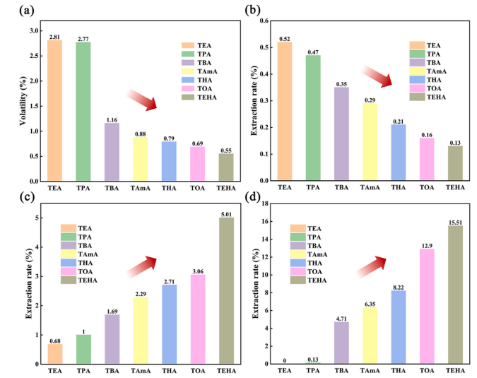Fig. 1. Stability performance tests of seven trans-aconitate plasticized PVCs: (a) Volatility test; (b) Water extraction test; (c) Ethanol extraction test; (d) Petroleum ether extraction test.

The maximum number of figures recommended within the main body of the paper is 8 for Research Article and Review, 2 for Short communication, Perspective, Letter, and Feature Article, 1 for Commentary and News & Views.
Ensure the figures are placed next to the relevant text in the manuscript, rather than at the bottom or the top of the file. The corresponding caption should be placed directly below the figure. The total number of words in the captions should not exceed 300 words.
In a multi-panel image, the sub-figure should be numbered as (a), (b), (c)…, which should be located in the upper left corner of the figure and placed outside of it. Ensure that both the entire image and each sub-figure should have captions. Keep text in the illustrations themselves to a minimum but explain all symbols and abbreviations used.
An image should be sized to 6.5 cm for the journal's double column format (i.e., an image to fit into the space of a single column on the 2-column layout) and 13.5 cm to span full columns (occupy the full-page width). Complicated figures should have a maximum width of 15 cm.
Notations in the figures should be distinct and consistent with the same ones in the text. The Arial font with a size of 6-8 pt is recommended. Only the first letter of the axis label should be capital.
Line drawings and graphs must have a resolution of at least 1200 dpi when they are exported. Photographs and micrographs must have resolution of at least 300 dpi (600 dpi if there is text or line art in the figure).
Figure should be abbreviated to Fig. for the whole paper.

Table 1. Preparation of the catalysts under different conditions.
Preparing methodª | Substrate^{b} | Temperature (°C) | Yield (%)
ª……
^{b}…….
Please submit tables as editable text and not as images.
Tables should be placed in the main text near to their first citation.
Number tables consecutively in accordance with their appearance in the text and place any table notes below the table body.
Be sparing in the use of tables and ensure that the data presented in them do not duplicate results described elsewhere in the article.
Please avoid using vertical rules and shading in table cells.

4. Conclusions
The main conclusions of the study may be presented in a short Conclusions section, which should stand alone when Results and Discussion sections are combined into a single section Results and Discussion.

Ethical statement
Interventionary studies involving animals or humans, and other studies that require ethical approval, must list the authority that provided approval and the corresponding ethical approval code in this section.

Author Contributions
For research articles with several authors, a short paragraph specifying their individual contributions must be provided using the relevant CRediT roles: Conceptualization; Data curation; Formal analysis; Funding acquisition; Investigation; Methodology; Project administration; Resources; Software; Supervision; Validation; Visualization; Roles/Writing - original draft; Writing - review & editing. Authorship statements should be formatted with the names of authors first and CRediT role(s) following. Sample author statement: “Zhang San: Conceptualization, Methodology, Software. Priya Singh.: Data curation, Writing- Original draft preparation. Wang Wu: Visualization, Investigation. Jan Jansen: Supervision. Ajay Kumar: Software, Validation. Sun Qi: Writing- Reviewing and Editing.”

Declaration of competing interest
The authors declare that they have no known competing financial interests or personal relationships that could have appeared to influence the work reported in this paper.

Acknowledgments
List all funding and other helps that support this work.
List here those individuals who provided help during the research (e.g., providing language help, writing assistance or proof reading the article, etc.).
List funding sources in this standard way to facilitate compliance to funder's requirements:
Funding: This work was supported by the National Natural Science Foundation of China (Grant Nos. xxxx, yyyy).
When funding is from a block grant or other resources available to a university, college, or other research institution, submit the name of the institute or organization that provided the funding.
If no funding has been provided for the research, please include the following sentence: This research did not receive any specific grant from funding agencies in the public, commercial, or not-for-profit sectors.
Funding information cannot be revised any more after paper acceptance.

Supplementary Material
Summarize the supplementary information in this section. Fig. S1: title, Table S1: title, Video S1: title.

Appendix A
If there is more than one appendix, they should be identified as A, B, etc. Formulae and equations in appendices should be given separate numbering: Eq. (A1), Eq. (A2), etc.; in a subsequent appendix, Eq. (B1) and so on. Similarly, for tables and figures: Table A1; Fig. A1, etc.
Appendix B
All appendix sections must be cited in the main text.

References

Reference to a journal publication:
[1] J. van der Geer, J.A.J. Hanraads, R.A. Lupton, The art of writing a scientific article, J. Sci. Commun. 163 (2010) 51–59.

Reference to a journal publication with an article number:
[2] J. van der Geer, J.A.J. Hanraads, R.A. Lupton, The art of writing a scientific article. Heliyon. 19 (2018) e00205.

Reference to a book:
[3] W. Strunk Jr., E.B. White, The Elements of Style, fourth ed., Longman, New York, 2000.

Reference to a chapter in an edited book:
[4] G.R. Mettam, L.B. Adams, How to prepare an electronic version of your article, in: B.S. Jones, R.Z. Smith (Eds.), Introduction to the Electronic Age, E-Publishing Inc., New York (2009) pp. 281–304.

Reference to a website:
[5] Cancer Research UK, Cancer statistics reports for the UK., 2003 (http://www.cancerresearchuk.org/aboutcancer/statistics/cancerstatsreport/, accessed 13 March 2003).

Reference to patent
[6] C.G. Bai, L. Murr, W. Smith, A Novel Method for Preparing Al Base MMC, US Patent, No.200101133, 2001.

Reference to a dataset:
[dataset] [7] M. Oguro, S. Imahiro, S. Saito, T. Nakashizuka, Mortality data for Japanese oak wilt disease and surrounding forest compositions, Mendeley Data, v1, 2015 (https://doi.org/10.17632/xwj98nb39r.1).

Reference to software:
[8] E. Coon, M. Berndt, A. Jan, D. Svyatsky, A. Atchley, E. Kikinzon, D. Harp, G. Manzini, E. Shelef, K. Lipnikov, R. Garimella, C. Xu, D. Moulton, S. Karra, S. Painter, E. Jafarov, S. Molins, Advanced Terrestrial Simulator (ATS) v0.88 (Version 0.88), Zenodo, March 25, 2020.

Please ensure that every reference cited in the text is also present in the reference list (and vice versa). References must be numbered in order of appearance in the text (including citations in tables and legends) and listed individually at the end of the manuscript.
Citations and references in the Supplementary Materials are permitted provided that they also appear in the reference list here.

Graphical Abstract

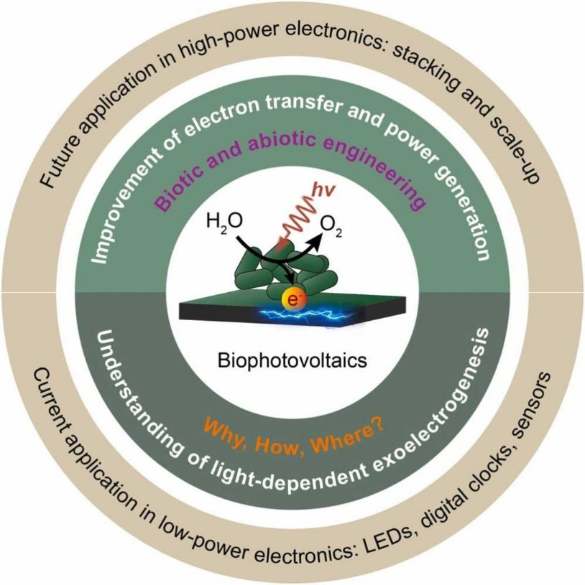
(A graphical abstract is mandatory for this journal as it draws more attention to the online article. The graphical abstract should summarize the contents of the article in a concise, pictorial form designed to capture the attention of a wide readership. Please provide an image with a minimum of 600 × 600 pixels (h × w) or proportionally more. The image should be readable using a minimum screen resolution of 300 dpi. Preferred file types: TIFF, JPG, EPS, PDF or MS Office files.)

