(Please note the blue marks are only for your information and should be deleted once the manuscript is finished.)
A concise and descriptive title
(Concise and informative. Titles are often used in information–retrieval systems. Avoid abbreviations and formulae where possible.)
Zhenhua Yan¹, Kai Zhang,^{1,2} Jun Chen^{1,2,*}
¹ Key Laboratory of Advanced Energy Materials Chemistry (Ministry of Education), College of Chemistry, Nankai University, Tianjin 300071, China
² Renewable Energy Conversion and Storage Center, College of Chemistry, Nankai
University, Tianjin 300071, China

*Corresponding author.
E-mail: chenabc@nankai.edu.cn (Chen J.) (use office email address)

Abstract (The abstract should be no more than 150 words)
Abstract contains a brief account of the background and rationale of the work, followed by a statement of the main conclusions introduced by the phrase “Here we show” or some equivalent. References should be avoided, but if essential, then cite the author(s) and year(s). Also, non-standard or uncommon abbreviations should be avoided, but if essential they must be defined at their first mention in the abstract itself.
Keywords: Electrodes; Batteries; Materials (3~6 words)
(Divide your article into clearly defined and numbered sections. Subsections should be numbered 1.1 (then 1.1.1, 1.1.2, ...), 1.2, etc. (the abstract is not included in section numbering). Use this numbering also for internal cross-referencing: do not just refer to 'the text'. Any subsection may be given a brief heading. Each heading should appear on its own separate line.)

Introduction
The introduction should be up to 500 words of referenced text expands on the background to the work, followed by a concise, focused account of the findings. State the objectives of the work and provide an adequate background, avoiding a detailed literature survey or a summary of the results [1]. The text should be in times new roman, 12-pt font and double spaced. The reference number should be shown like this in order [2,5–6].
Material and methods
Provide sufficient details to allow the work to be reproduced by an independent researcher. Methods that are already published should be summarized, and indicated by a reference. If quoting directly from a previously published method, use quotation marks and also cite the source. Any modifications to existing methods should also be described.
Theory/calculation
A Theory section should extend, not repeat, the background to the article already dealt with in the Introduction and lay the foundation for further work. In contrast, a Calculation section represents a practical development from a theoretical basis.
The reaction was carried out under ..condition. The yield of catalyst is calculated according to Eq. (1).
Yield (%) = a/b (1)
(Please submit math equations as editable text and not as images. Present simple formulae in line with normal text where possible and use the solidus (/) instead of a horizontal line for small fractional terms, e.g., X/Y. In principle, variables are to be presented in italics. Powers of e are often more conveniently denoted by exp. Number consecutively any equations that have to be displayed separately from the text (if referred to explicitly in the text).)

Results and discussion
Results should be clear and concise. Discussion should explore the significance of the results of the work, not repeat them. A combined Results and Discussion section is often appropriate. Avoid extensive citations and discussion of published literature.
The reaction process is shown in Scheme 1.
The catalyst is characterized using SEM (Fig. 1a). As shown in Fig. 1(b), ….
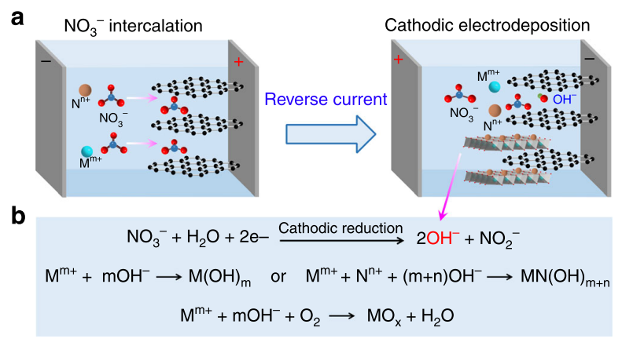
Figure 1. Electrodeposition strategy and principles. a, A schematic two-step synthesis using graphite substrate and nitrate precursors. b, The reaction mechanisms of the cathodic electrodeposition of metal hydroxides (M(OH)_{m} or MN(OH)_{m + n}), and oxides (MO_{x}). M^{m+} and N^{n+} are metal cations.

(The figures should be numbered as a, b, c…. Only the first letter of the axis label should be capital. No more than 8 figures are allowed in a Research Article. Ensure that each illustration has a caption. Supply captions separately, not attached to the figure. A caption should comprise a brief title (not on the figure itself) and a description of the illustration. Keep text in the illustrations themselves to a minimum but explain all symbols and abbreviations used. When the manuscript is accepted, the authors need to submit editable images of the main text separately.)

Table 1. Preparation of the catalysts under different conditions.
Preparing methodª | Substrate^{b} | Temperature (°C) | Yield (%)
ª……
^{b}…….
(Please submit tables as editable text and not as images. Tables can be placed either next to the relevant text in the article, or on separate page(s) at the end. Number tables consecutively in accordance with their appearance in the text and place any table notes below the table body. Be sparing in the use of tables and ensure that the data presented in them do not duplicate results described elsewhere in the article. Please avoid using vertical rules and shading in table cells.)

Conclusions
The main conclusions of the study may be presented in a short Conclusions section, which may stand alone or form a subsection of a Discussion or Results and Discussion section.

Author contributions
J. Chen proposed the concept. Z.H. Yan performed the experiments. Z.H. Yan, K. Zhang and J. Chen. co-wrote the manuscript. All authors participated in data analysis and manuscript discussion.

Additional Information
Supplementary material such as applications, images, sound clips and videos, can be published with your article to enhance it. Submitted supplementary items are published exactly as they are received. Please submit your material together with the article and supply a concise, descriptive caption for each supplementary file. If you wish to make changes to supplementary material during any stage of the process, please make sure to provide an updated file. Do not annotate any corrections on a previous version. Please switch off the 'Track Changes' option in Microsoft Office files as these will appear in the published version.
(If there is more than one appendix, they should be identified as A, B, etc. Formulae and equations in appendices should be given separate numbering: Eq. (A.1), Eq. (A.2), etc.; in a subsequent appendix, Eq. (B.1) and so on. Similarly for tables and figures: Table A.1; Fig. A.1, etc.)

Competing financial interests
The authors declare no competing financial interests.

Acknowledgments
List all funding and other helps that support this work.
(List here those individuals who provided help during the research (e.g., providing language help, writing assistance or proof reading the article, etc.).
List funding sources in this standard way to facilitate compliance to funder's requirements:
Funding: This work was supported by the National Natural Science Foundation of China (grant numbers xxxx, yyyy).
It is not necessary to include detailed descriptions on the program or type of grants and awards. When funding is from a block grant or other resources available to a university, college, or other research institution, submit the name of the institute or organization that provided the funding.
If no funding has been provided for the research, please include the following sentence: This research did not receive any specific grant from funding agencies in the public, commercial, or not-for-profit sectors.)

References
(For research articles, the number of references is generally around 40.)
Reference to a journal publication:
- F.Y. Cheng, J. Shen, B. Peng, Y.D. Pan, Z.L. Tao, J. Chen, Rapid room–temperature synthesis of nanocrystalline spinels as oxygen reduction and evolution electrocatalysts, Nat. Chem. 3 (2011) 79–84.

An example of a citation using DOI for an article not yet in an issue is:

- J. van der Geer, J.A.J. Hanraads, R.A. Lupton, 2018. The art of writing a scientific article. Heliyon. 19, e00205. https://doi.org/10.1016/j.heliyon.2018.e00205.
Reference to a book:
- J.W. Strunk, E.B. White, 1979. The Elements of Style, third ed. Macmillan, New York.
Reference to a chapter in an edited book:
- G.R. Mettam, L.B. Adams, How to prepare an electronic version of your article, in: B.S. Jones, R.Z. Smith, (Eds.), Introduction to the Electronic Age. E–Publishing Inc., New York, 1999, pp. 281–304.

Graphical Abstract
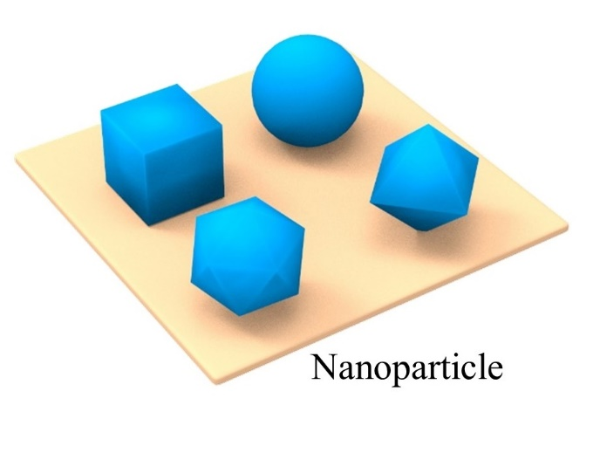
(A graphical abstract is mandatory for this journal as it draws more attention to the online article. The graphical abstract should summarize the contents of the article in a concise, pictorial form designed to capture the attention of a wide readership. Please provide an image with a minimum of 600 × 600 pixels (h × w) or proportionally more. The image should be readable using a minimum screen resolution of 300 dpi. Preferred file types: TIFF, JPG, EPS, PDF or MS Office files.)

