**International Journal of Sediment Research**

**Manuscript Format**

* **Title Page**
* **Title**

Only the first letter of the first word and proper nouns should be capitalized.

For example, “Phosphorus forms and distribution in the Zhejiang coastal sediment in the East China Sea”.

* **Author names and affiliations**

Use full names, but not initials, for all the authors’ names. The author’s given name should be written before surname, and only the first letter of surname or given name should be capitalized. The corresponding author must be clearly indicated with an asterisk (*).

For the affiliations, if the authors are from the same affiliation, then the same superscript (a, b, c…) should be marked on each author’s name.

The standard format for author names and affiliations is shown below.

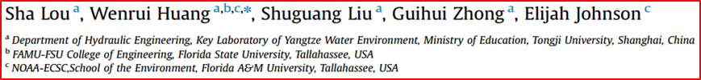



* **Subsections**

Subsections should be consecutively numbered 1. (then 1.1., 1.2., 1.3., ...), 2., 3., etc. But the abstract is not included in section numbering. In subsection titles, only the first letter of the first word and proper nouns should be capitalized.

For example, “1. Introduction 2. Material and methods 3. Results 4. Discussion 5. Conclusions” and “2.1. Data collection 2.2. Modeling with Saint-Venant equations”.

* **Text Formatting**
  + - 1. All text, including the abstract and reference list, should be prepared in single-column and double-spaced format. Manuscripts are recommended to be submitted in Microsoft Word. Use a normal, plain font (e.g., 12-point Times Roman) for text, and add line numbers on the left side.
      2. There must be a space between units and values with the exception of: degree (only as angle), arc minute and arc second signs [°, ´ (U+2032) and ´´ (U+2033)], which are closed up. Note: °C, %, and ‰ are to be used with a space, in accordance with SI policy.
* The maximum number of words and word-equivalents (including figures and tables) is 10,000 for technical papers, and 3,000 for technical notes. Please note that each figure or table is regarded as 160 word-equivalents.
* **Figures**

1. Original figures should be in high quality with the resolution of 600dpi and saved as filename.tif or filename.jpg. The figures may also be made by Microsoft excel.
2. Figures should be in the proper size, less than 8 cm or 16 cm in width, and less than 24 cm in height. When making a figure, please set the size first, then write down words, numbers, symbols, etc.
3. Use a normal, uniform font (Times New Roman, 9 points, no bold) for all the words and numbers in figures. Physical quantity symbols need to be in italics, and noun phrases, units, and numbers need to be in non-italic font.
4. Only the first letter of the first word should be capitalized, except proper nouns.
5. Lines in the figure should be clear and in black with medium line thickness.
6. A ‘thousands separator’, in the form of a fixed horizontal space or comma (follow the author's usage) must be used for numbers greater than 9999. Delete thousands separators and commas used for numbers below 10,000 (e.g. 1,500 must be 1500).
7. The unit in axis titles should be enclosed in parentheses, for example, “Flow discharge (m3/s)”.
8. Rotate the y-axis title by 90 degrees counterclockwise, as shown below.

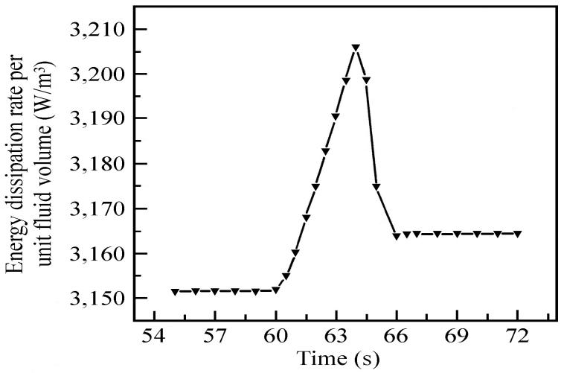

1. The background of figures should be deleted.
2. If there are 2 subfigures in one figure, it’s suggested to place one on the left side, and the other on the right side. The width of each subfigure should be less than 8 cm. If there are 4 subfigures (abcd), then it’s suggested to place subfigure a on the top left side, b on the top right side, c on the bottom left side, and d on the bottom right side.
3. If there are subfigures in one figure, (a), (b), (c)… in lowercase with parentheses should be used for notation both in figures and captions.

* **Tables**

1. Use a normal, uniform font ( Times New Roman, 9 points, no bold) for all the words and numbers in tables. Physical quantity symbols need to be in italics, and noun phrases, units, and numbers need to be in non-italic font.
2. Only the first letter of the first word in line one should be capitalized, except proper nouns.
3. A ‘thousands separator’, in the form of a fixed horizontal space or comma (follow the author's usage) must be used for numbers greater than 9999. Delete thousands separators and commas used for numbers below 10,000 (e.g. 1,500 must be 1500).

* **Citations and References**

International Journal of Sediment Research (IJSR) use the following formats for the text citation and reference list.

Please note that they are a bit different from the standard APA 6th.

**Citations in Text**

1. **One Author**

- Smith (2002) found…

- (Smith, 2002)

1. **Two Authors**

- Smith and Jones (2003) found…

- (Smith & Jones, 2003)

1. **Three or More Authors**

- Smith et al. (2002) found…

- (Phelps et al., 2004)

1. **Groups as Authors:**

- 1st Citation:

(American Psychological Association [APA], 2000)

- Subsequent Citations:

(APA, 2000)

1. **Anonymous or No Author**

- Use first few words of reference list entry (usually title):

(“Study Finds,” 1995)

(TEA, 2007)

1. **Authors with Same Surname**

- Include initials: S. T. Smith (2000) and J. D. Smith (1999)

1. **Two or more works within the same parentheses**

- In order alphabetically, as they would appear in references, separated by semi-colons

(Jones, 2010; Thomas, 2003)

- If by same author, then by date

(Jones, 2003, 2007)

**Reference List**

The reference list is titled References and they are: double spaced, in alphabetical order, and formatted with a “hanging indention”.

1. **Journal Article**

**Accessed in print**

All authors should be listed.

Carlson, L. A. (2003). Existential theory: Helping school counselors attend to youth at risk for violence. *Professional School Counseling, 6*(5), 10-15.

Sagarin, B. J., & Lawler-Sagarin, K. A. (2005). Critically evaluating competing theories: An exercise based on the Kitty Genovese murder. *Teaching of Psychology, 32*(3), 167-169.

Hughes, J. C., Brestan, E. V., & Valle, L. A. (2004). Problem-solving interactions between mothers and children. *Child and Family Behavior Therapy, 26*(1), 1-16.

**Accessed electronically with DOI**

Herbst-Damm, K.L., & Kulik, J.A. (2005). Volunteer support, marital status, and the survival times of terminally ill patients. *Health Psychology, 24*, 225-229. doi: 10.1037/0278-6133.24.2.225

**Accessed electronically without DOI**

Give URL: Retrieved from http://www.xx (prefer the journal website and not the link directly through the database, for access reasons)

Silick, T.J., & Schutte, N.S. (2006). Emotional intelligence and self-esteem mediate between perceived early parental love and adult happiness. *E-Journal of Applied Psychology, 2(2*), 38-48. Retrieved from <http://ojs.lib.swin.edu.au/index.php/ejap>

1. **Books**

**Entire Book:**

Beck, C. A. J., & Sales, B. D. (2001). *Family mediation: Facts, myths, and future prospects.* Washington, DC: American Psychological Association.

For electronic versions use

- doi if provided and no publishing location or

- Retrieved from http://www.websitename.org

- No retrieval date necessary

**Chapter in an edited book:**

Johnson, R. A. (1989). Retrieval inhibition as an adaptive mechanism in human memory. In H. L. Roediger III & F. I. M. Craik (Eds.), *Varieties of memory & consciousness* (pp. 309-330). Hillsdale, NJ: Erlbaum.

**English translation of a book:**

Lang, P. S. (1951). *A philosophical essay on probabilities* (F. W. Truscott & F. L. Emory, Trans.). New York, NY: Dover. (Original work published 1814)

* In text, cite original date and translation date: (Lang, 1814/1951).

1. **Technical and Research Reports**

Author, A. A. (1998). *Title of work* (Report No. xxx). Location: Publisher.

**Corporate author, government report**

U.S. Department of Health and Human Services, National Institutes of Health, National Heart, Lung, and Blood Institute. (2003). *Managing asthma: A guide for schools* (NIH Publication No. 02-2650). Retrieved from <http://www.nhlbi.nih.gov/health/prof/lung/asthma/asth_sch.pdf>

**Authored report, from nongovernmental organization**

Kessy, S. S. A., & Urio, F. M. (2006). *The contribution of microfinance institutions to poverty reduction in Tanzania* (Research Report No. 06.3). Retrieved from Research on Poverty Alleviation website: <http://www.repoa.or.tz/documents_storage/Publications/Reports/06.3_Kessy_and_Urio.pdf>

1. **Dissertations and Theses**

**Source: Dissertations and Theses database**

Pecore, J. T. (2004). *Sounding the spirit of Cambodia: The living tradition of Khmer music and dance-drama in a Washington, DC community* (Doctoral dissertation). Retrieved from Dissertations and Theses database. (UMI No. 3114720)

**Source: Free Web**

Caprette, C. L. (2005). *Conquering the cold shudder: The origin and evolution of snake eyes* (Doctoral dissertation). Retrieved from <http://www.ohiolink.edu/etd/send-pdf.cgi?acc_num=osu1111184984>

**Source: In Print**

Caprette, C. L. (2005). *Conquering the cold shudder: The origin and evolution of snake eyes* (Doctoral dissertation). Ohio State University, Columbus, OH.

1. **Meetings and Symposia**

**Proceedings published in book form**

Katz, I., Gabayan, K., & Aghajan, H. (2007). A multi-touch surface using multiple cameras. In J. Blanc-Talon, W. Philips, D. Popescu, & P. Scheunders (Eds.), *Lecture Notes in Computer Science: Vol. 4678. Advanced Concepts for Intelligent Vision Systems* (pp. 97-108). Berlin, Germany: Springer-Verlag. doi: 10.1007/978-3-540-74607-2_9

**Proceedings published regularly online**

Herculano-Houzel, S., Collins, C. E., Wong, P., Kaas, J. H., & Lent, R. (2008). The basic nonuniformity of the cerebral cortex. *Proceedings of the National Academy of Sciences 105*, 12593-12598. doi: 10.1073/pnas.0805417105

**Conference paper abstract retrieved online**

Liu, S. (2005, May). *Defending against business crises with the help of intelligent agent based early warning solutions*. Paper presented at the Seventh International Conference on Enterprise Information Systems, Miami, FL. Abstract retrieved from <http://www.iceis.org/iceis2005/abstracts_2005.htm>

**Symposium contribution**

Muellbauer, J. (2007, September). Housing, credit, and consumer expenditure. In S. C. Ludvigson (Chair), *Housing and consumer behavior*. Symposium conducted at the meeting of the Federal Reserve Bank of Kansas City, Jackson Hole, WY.

1. **Reference in Other Language**

Hughes, J. C., Brestan, E. V., & Valle, L. A. (2004). Problem-solving interactions between mothers and children. *Child and Family Behavior Therapy, 26*(1), 1-16. (*In Chinese*)